# Application Letter

Evan O’Neill

Evanoneill147@gmail.com

01/02/2024

Dear [Hiring manager's name],

I'm writing to express my interest in the position of Data Scientist at Microsoft. I heard of this position from LinkedIn, I Found it interesting as I believe my skills in Databases like Oracle and SQL whilst my Certifications in AWS and My Level 5 Degree in Computing make me an ideal fit for this job. I appreciate and understand that Data Science is a pivotal part of a successful company especially Microsoft, as you must deal with Big Data and several internal/external problems with that data. I believe my skill set will provide a perfect match for this job.

I have previously worked with Data in Bunzl, where my role was Sales Data Admin. I Supervised several different successful Projects. My Primary Goal was to increase Sale Leads through Several different Markets which I achieved through using Large Data Sets. I Prioritized Customer interaction as my main point of data entry to ensure the authenticity this led to less mistakes and more productivity. This ensured all aspects of the project was successful. My previous experience shows my drive to continually improve and succeed that’s why I think I’m perfect for this Job.

Thank you for taking the time to read my Application Letter. I hope to speak with you soon and learn about this opportunity at Microsoft.

Sincerely,

Evan O’Neill

# Thank you Letter

Dear Mr. Gold

Thank you for taking the time to meet with me today. I enjoyed learning more about the Data Scientist position within Microsoft. It’s an excellent match for my skills and interests, given my background as an Data analyst.

Your modern approach to Data, in particular Big Data, confirmed my desire to become a member of your team.

In addition to my work ethic, I’d also bring my Data Analytic Expertise, time management skills and team player attitude to the department.

Thank you for reserving an hour out of your extremely busy schedule to interview me today. I remain very interested in becoming a member of your team and look forward to speaking with you again!

Sincerely,

Evan O’Neill

# Written draft (letter of thanks)

# CV



# Personal Profile

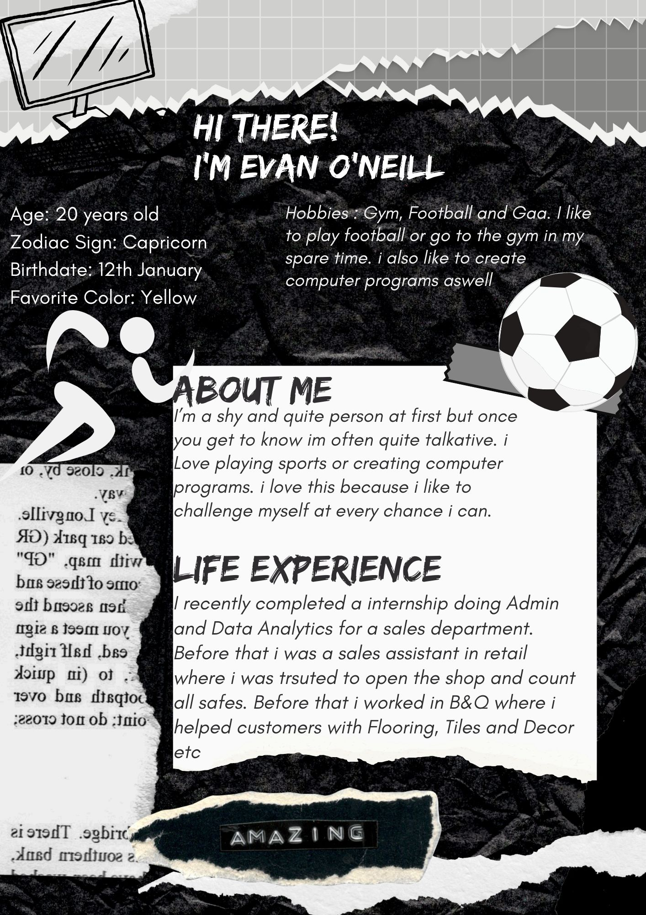

# Susi Reflection

# Excel Skills Audit

# Written Reflection of Skills Audit

